Question 1 :- Create a Student table with appropriate data types and constraints.
- Create a Student table
CREATE TABLE Student_DETAILS(
student_id INT PRIMARY KEY,
first_name VARCHAR(50) NOT NULL,
last_name VARCHAR(50) NOT NULL,
mob_no NUMBER (10) NOT NULL,
email VARCHAR(100)UNIQUE,
date_of_birth DATE
);
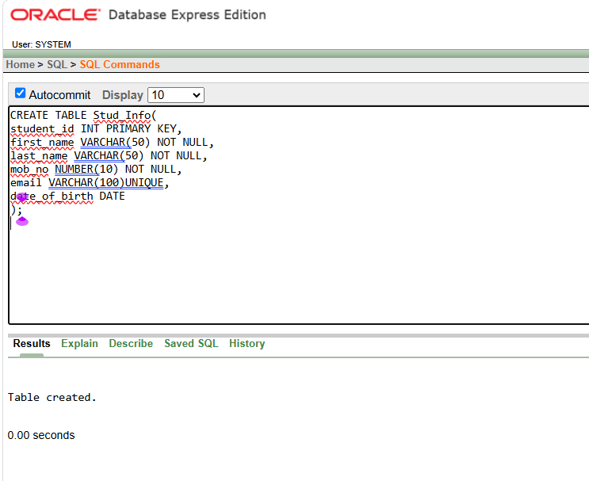
- Insert Data Into Table :-
INSERT INTO Stud_Info (student_id,first_name,last_name,mob_no,email,date_of_birth)
VALUES(1,'BHAVESH','DANDAVATE',8909897898, 'bhavesh@gmail.com', '01-JAN-2005');
INSERT INTO Student_DETAILS (student_id,first_name,last_name,mob_no,email,date_of_birth)
VALUES(2,'RUSHIKESH','GARADE',2563256985,'rushikesh@gmail.com','03-FEB-2005');
INSERT INTO Student_DETAILS (student_id,first_name,last_name,mob_no,email,date_of_birth)
VALUES(3,'VISHWJEET','BHINGARDEV',3562145236,'vishu@gmail.com','05-NOV-2005');
INSERT INTO Student_DETAILS (student_id,first_name,last_name,mob_no,email,date_of_birth)
VALUES(4,'YASH','THORAT',2145236589,'yash@gmail.com','06-MARCH-2005');
INSERT INTO Student_DETAILS (student_id,first_name,last_name,mob_no,email,date_of_birth)
VALUES(5,'VIRAJ','NALWADE',1452897563,'viraj@gmail.com','09-DEC-2005');
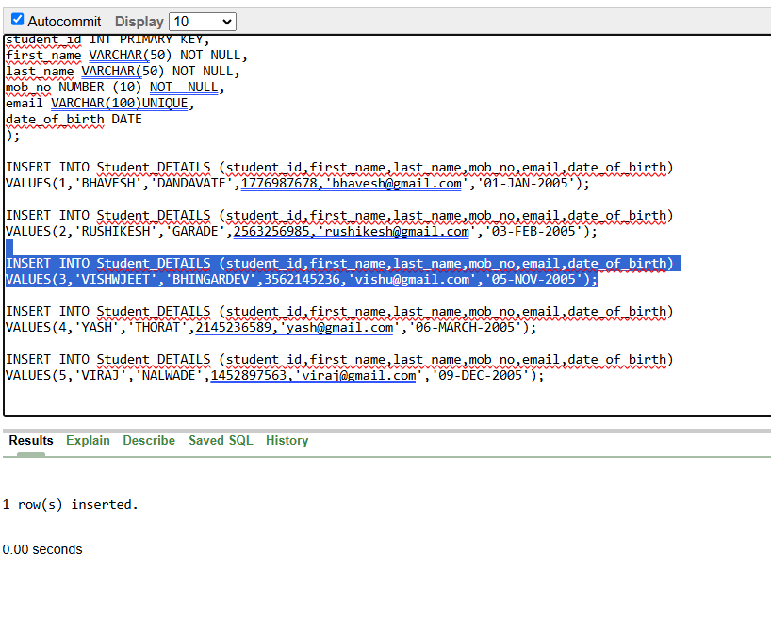
- Show Table :-
SELECT*FROM Student_DETAILS;
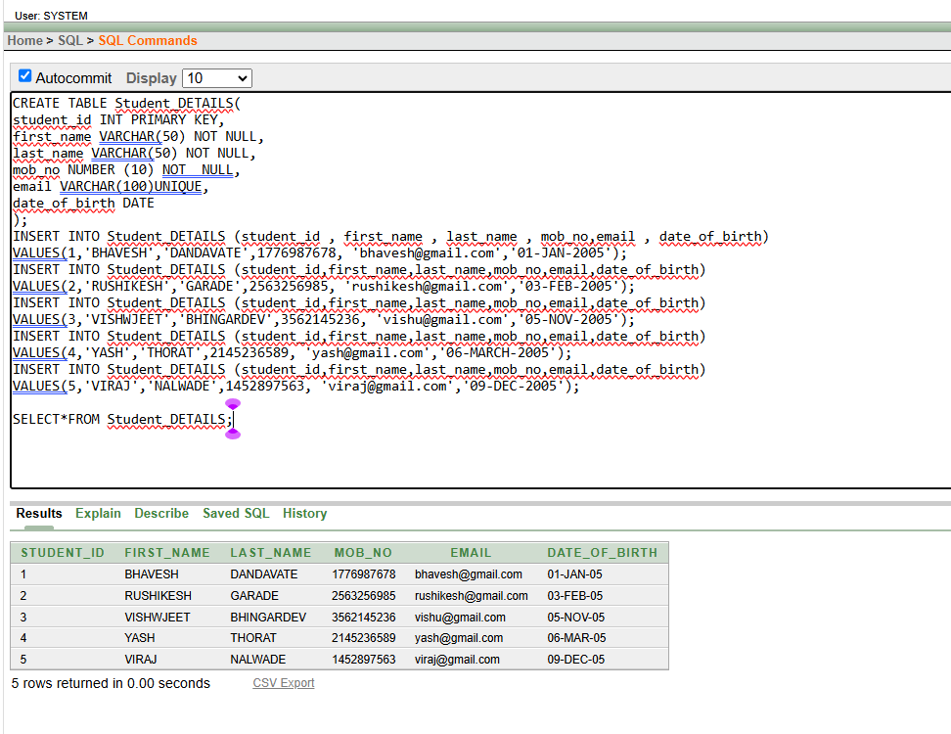
Question 2 :- Perform DDL Operations :- ALTER,RENAME,TRUNCATE and DROP on the student table .
a) ALTER ADD :-
Query :- ALTER TABLE Student_DETAILS ADD address VARCHAR(100); O/P :- Table altered.
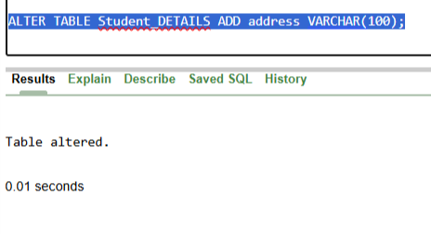
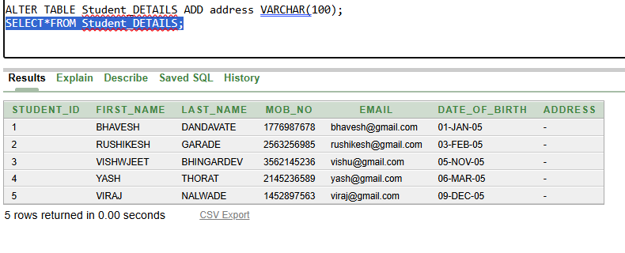
b)UPDATE :-
Query :-
UPDATE Student_DETAILS SET date_of_birth='05-JAN-2004';
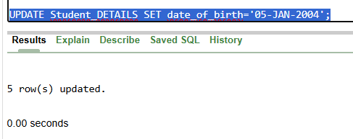

O/P :- 5 row(s) updated

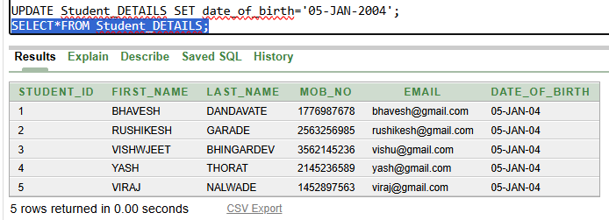

c) RENAME column / table :-
- Query for Rename column :-
ALTER TABLE Student_DETAILS RENAME COLUMN mob_no TO mobile_number;
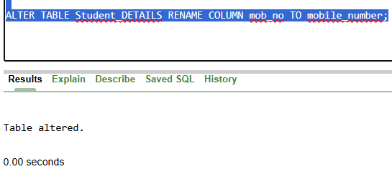
O/P :- Table altered / Statement processed
- Query for Rename Table :-
RENAME Student_DETAILS TO STUD_DETAILS;
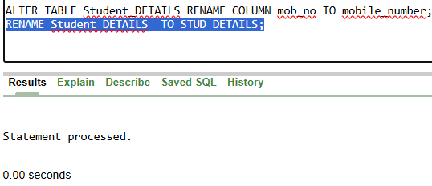

O/P :- Statement processed

d) TRUNCATE Table :-
TRUNCATE TABLE STUD_DETAILS;

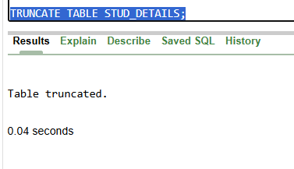

O/P :- Table truncated.

e) DROP Table :-
DROP TABLE STUD_DETAILS;

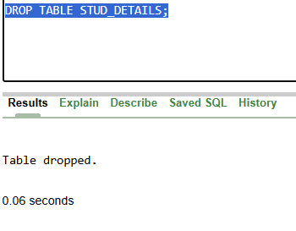

O/P :- Table Dropped.

